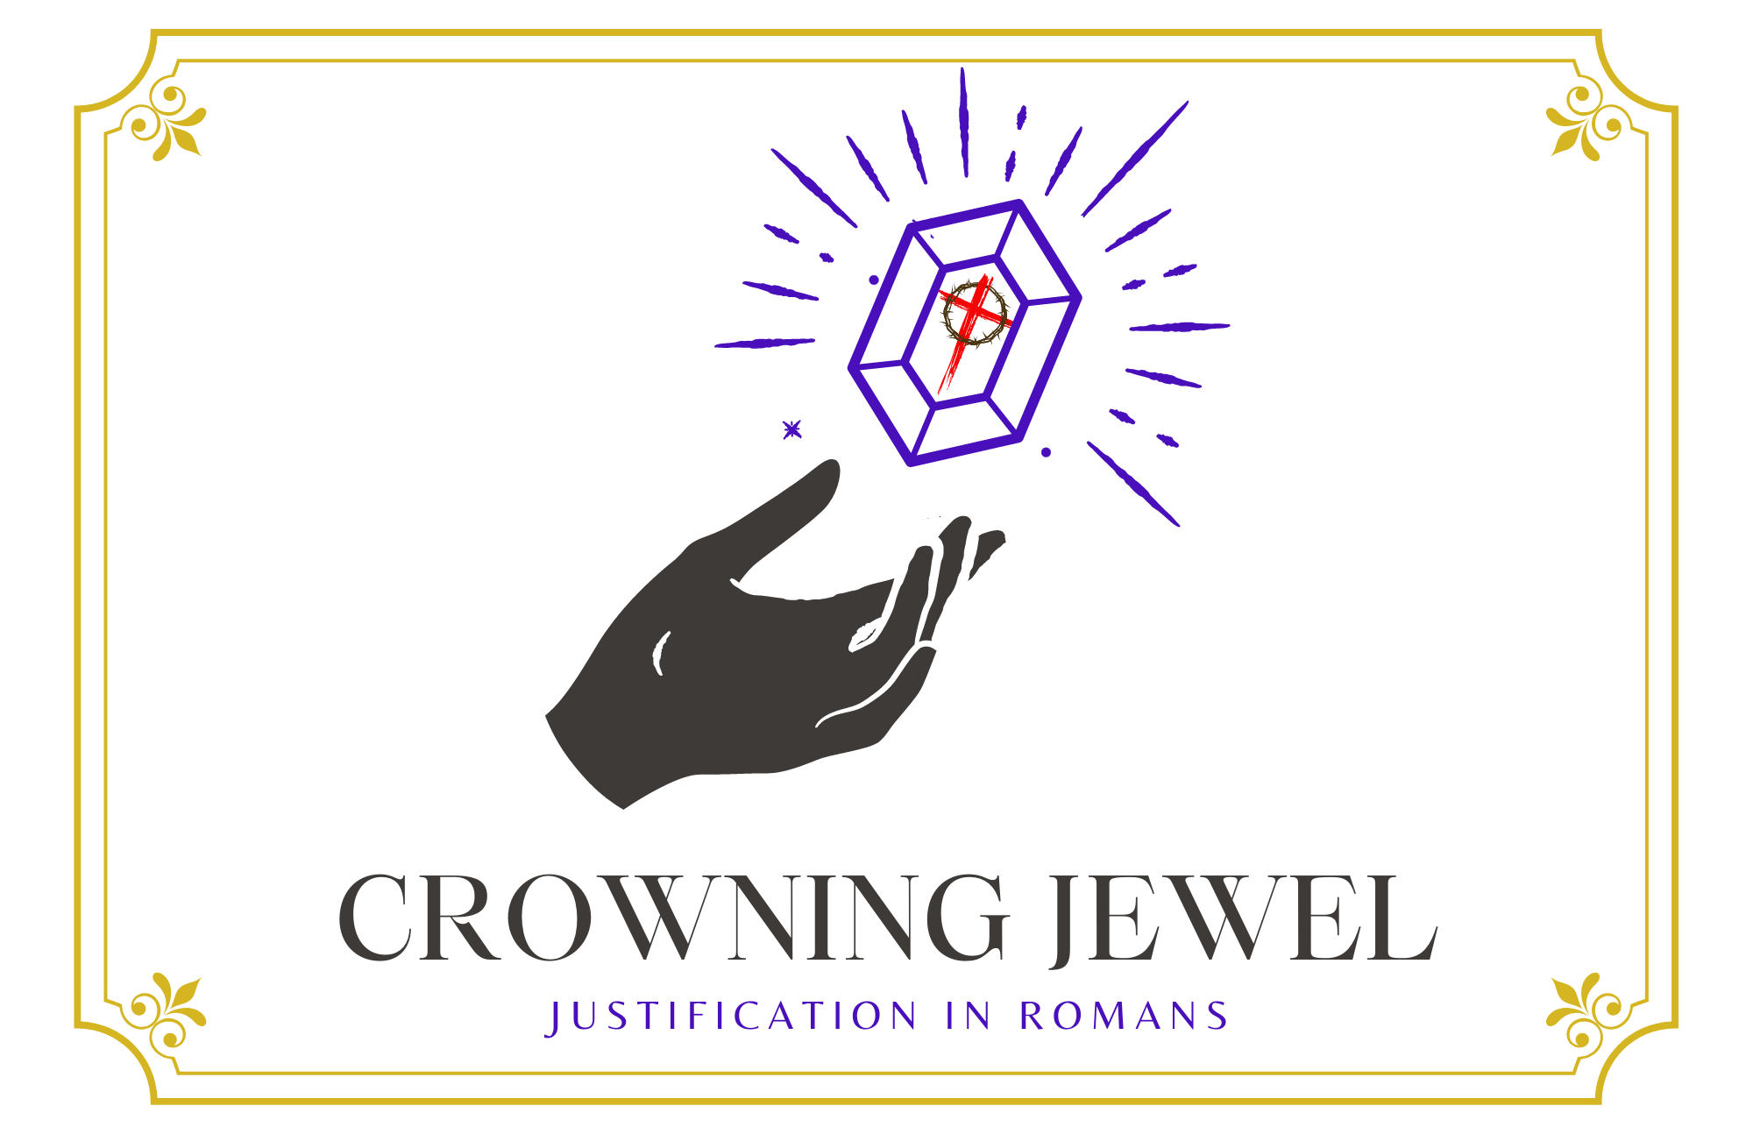

3rd Sunday in Lent

CHRIST LUTHERAN CHURCH | Lodi, California
March 3, 2024

WELCOME TO WORSHIP
Welcome to Christ Lutheran Church. We pray that your soul will be strengthened by the good news about God’s grace, love, and forgiveness given to us. If you would like to learn more about our church, please speak with our pastor or one of our members after the service.
- Bathrooms are located in the fellowship hall. A changing table is located in the women’s bathroom.
WORSHIP THEME
Christ is our life. Though we wait for the Last Day and the resurrection of the dead, we wait in hope to know that we will rise with Christ. We also live in Christ today: since we are in Christ, we are set free from sin and death.
One theologian has called justification the crowning jewel of Christian doctrine. Like a finely cut gemstone, this teaching of the Bible has many facets, and every time we examine it from a different angle, new truths and fresh insights come into view like light reflecting from its face. During the season of Lent, we will examine some of the various aspects of what Christ accomplished for us.

The Common Service
The high and holy worship of God is faith in Jesus Christ. Such faith is created and sustained by God’s service to us (the German, “Gottesdienst,” “The Divine Service”). In the Divine Service, the Lord comes to us in His Word and Sacrament to bless and enliven us with His gifts. The Service is not something we do for God, but His service to us received in faith. The liturgy is God’s work. He gives, we receive.
HYMN Today Your Mercy Calls Us | CW 339

INVOCATION
M: In the name of the Father, and of the Son ✙ and of the Holy Spirit
C: Amen.
CONFESSION
M: Beloved in the Lord: let us draw near with a true heart and confess our sins to God our Father, asking him in the name of our Lord Jesus Christ to grant us forgiveness.
From God’s Word we know that wherever God puts His name, there He is to bless. In the Old Testament the temple was the place where God graciously caused His name to be present (1 Kings 8:27-30).
God has put His name —Father, Son, and Holy Spirit—on us in Holy Baptism. The Divine Service begins with the Invocation, the words spoken over us at our baptisms. Every Divine Service is for the hallowing of the Lord’s name, which the Small Catechism reminds us is done “when the Word of God is taught in its truth and purity, and we, as the children of God, also lead holy lives according to it” (Matthew 28:18-20).
C: Holy and merciful Father, I confess that I am by nature sinful, and that I have disobeyed you in my thoughts, words, and actions. I have done what is evil and failed to do what is good. For this I deserve your punishment both now and in eternity. But I am truly sorry for my sins, and trusting in my Savior Jesus Christ, I pray: Lord, have mercy on me, a sinner.
Lord, have mercy on us. Christ, have mercy on us. Lord, have mercy on us.

absolution
M: God, our heavenly Father, has been merciful to us and has given his only Son to be the atoning sacrifice for our sins. Therefore, as a called servant of Christ and by his authority, I forgive you all your sins in the name of the Father and of the Son ✙ and of the Holy Spirit.
C: Amen
PRAYER OF THE DAY
M: The Lord be with you.
C: And also with you.
M: Let us pray.
Almighty God, look with favor on your humble servants and stretch out the right hand of your power to defend us against all our enemies; through Jesus Christ, your Son, our Lord, who lives and reigns with you and the Holy Spirit, one God, now and forever.
C: Amen
FIRST LESSON Exodus 20:1–17
The Ten Commandments give us a guide to a life of service to God. But they begin with the reason why we live this life: The Lord has redeemed us from slavery to sin.
20 And God spoke all these words:
² “I am the Lord your God, who brought you out of Egypt, out of the land of slavery.
³ “You shall have no other gods before me.
⁴ “You shall not make for yourself an image in the form of anything in heaven above or on the earth beneath or in the waters below. ⁵ You shall not bow down to them or worship them; for I, the Lord your God, am a jealous God, punishing the children for the sin of the parents to the third and fourth generation of those who hate me, ⁶ but showing love to a thousand generations of those who love me and keep my commandments.
⁷ “You shall not misuse the name of the Lord your God, for the Lord will not hold anyone guiltless who misuses his name.
⁸ “Remember the Sabbath day by keeping it holy. ⁹ Six days you shall labor and do all your work, ¹⁰ but the seventh day is a sabbath to the Lord your God. On it you shall not do any work, neither you, nor your son or daughter, nor your male or female servant, nor your animals, nor any foreigner residing in your towns. ¹¹ For in six days the Lord made the heavens and the earth, the sea, and all that is in them, but he rested on the seventh day. Therefore the Lord blessed the Sabbath day and made it holy.
¹² “Honor your father and your mother, so that you may live long in the land the Lord your God is giving you.
¹³ “You shall not murder.
¹⁴ “You shall not commit adultery.
¹⁵ “You shall not steal.
¹⁶ “You shall not give false testimony against your neighbor.
¹⁷ “You shall not covet your neighbor’s house. You shall not covet your neighbor’s wife, or his male or female servant, his ox or donkey, or anything that belongs to your neighbor.”

PSALM Psalm 19, page 70
SECOND LESSON Romans 8:1–10
Christ is our life: though sin and death had reigned over us, Christ has set us free from condemnation.
8 Therefore, there is now no condemnation for those who are in Christ Jesus, ² because through Christ Jesus the law of the Spirit who gives life has set you free from the law of sin and death. ³ For what the law was powerless to do because it was weakened by the flesh, God did by sending his own Son in the likeness of sinful flesh to be a sin offering. And so he condemned sin in the flesh, ⁴ in order that the righteous requirement of the law might be fully met in us, who do not live according to the flesh but according to the Spirit.
⁵ Those who live according to the flesh have their minds set on what the flesh desires; but those who live in accordance with the Spirit have their minds set on what the Spirit desires. ⁶ The mind governed by the flesh is death, but the mind governed by the Spirit is life and peace. ⁷ The mind governed by the flesh is hostile to God; it does not submit to God’s law, nor can it do so. ⁸ Those who are in the realm of the flesh cannot please God.
⁹ You, however, are not in the realm of the flesh but are in the realm of the Spirit, if indeed the Spirit of God lives in you. And if anyone does not have the Spirit of Christ, they do not belong to Christ. ¹⁰ But if Christ is in you, then even though your body is subject to death because of sin, the Spirit gives life because of righteousness.
VERSE OF THE DAY John 3:14,15
Just as Moses lifted up the snake in the desert, so the Son of Man must be lifted up, that everyone who believes in him may have eternal life.
THE GOSPEL John 2:13–22
Christ cleared the temple courts. His authority to do so? He is the Lord of life and death who will raise the temple of his own body from the grave.
¹³ When it was almost time for the Jewish Passover, Jesus went up to Jerusalem. ¹⁴ In the temple courts he found people selling cattle, sheep and doves, and others sitting at tables exchanging money. ¹⁵ So he made a whip out of cords, and drove all from the temple courts, both sheep and cattle; he scattered the coins of the money changers and overturned their tables. ¹⁶ To those who sold doves he said, “Get these out of here! Stop turning my Father’s house into a market!” ¹⁷ His disciples remembered that it is written: “Zeal for your house will consume me.”
¹⁸ The Jews then responded to him, “What sign can you show us to prove your authority to do all this?”
¹⁹ Jesus answered them, “Destroy this temple, and I will raise it again in three days.”
²⁰ They replied, “It has taken forty-six years to build this temple, and you are going to raise it in three days?” ²¹ But the temple he had spoken of was his body. ²² After he was raised from the dead, his disciples recalled what he had said. Then they believed the scripture and the words that Jesus had spoken.

M This is the Gospel of the Lord.
C: Praise be to you, O Christ!

NICENE CREED
We believe in one God, Dt. 6:4
the Father, the Almighty, 2 Cor. 6:18
maker of heaven and earth, Is. 51:13
The Nicene Creed is the great Confession of the Christian faith professed by all Christians. The Creed originated at the First Council of Nicaea (c. AD. 325)
of all that is, seen and unseen. Col. 1:16
We believe in one Lord, Jesus Christ, 1 Cor 8:6
the only Son of God, Jn. 3:16
eternally begotten of the Father, Heb. 1:2,5
God from God, Light from Light, true God from true God, Jn. 1
begotten, not made, of one being with the Father. Jn. 10:30
Through him all things were made. Jn. 1:3
For us and for our salvation, 1 Th. 5:9
he came down from heaven, Jn. 6:38
was incarnate of the Holy Spirit and the virgin Mary, Lk. 1:35
The Creed itself was crafted as a confession of Scripture in opposition to the Arian heresy, which denied that the Lord Jesus and the Holy Spirit are God.

and became fully human. Gal. 4:4
For our sake he was crucified under Pontius Pilate. Mk. 15:15
He suffered death and was buried. 1 Cor. 15:3-4a
On the third day he rose again in accordance
with the Scriptures. 1 Cor. 15:4b
He ascended into heaven Ac. 2:33-34
and is seated at the right hand of the Father. Heb. 1:13
He will come again in glory Mt. 25:31
to judge the living and the dead, 2 Tim. 4:1
and his kingdom will have no end. Lk. 1:33

We believe in the Holy Spirit, the Lord, the giver of life, Job 33:4
who proceeds from the Father and the Son, Jn. 15:26
who in unity with the Father and the Son Jn. 4:24
is worshiped and glorified,
who has spoken through the prophets. 2 Pet. 1:25
We believe in one holy Christian Mt. 16:18; Eph. 2:19-20
and apostolic Church.
We acknowledge one baptism for the forgiveness of sins. Eph. 4:5; Ac. 2:38
We look for the resurrection of the dead 1 Cor. 15:21-22
and the life of the world to come. Amen. Rev. 22

HYMN OF THE DAY Chief of Sinners Though I Be| CW 385
SERMON Romans 8

OFFERTORY
C: Create in me a clean heart, O God,
And renew a right spirit within me.
Cast me not away from your presence
And take not your Holy Spirit from me.
Restore unto me the joy of your salvation,
And uphold me with your free Spirit. Amen.
OFFERING
In response to God’s love and forgiveness, we give back a portion of what he has given us. The members of Christ Lutheran Church have joined to proclaim the gospel to this community. These offerings support that work. While our guests are welcome to participate, they should not feel obligated to do so.

PRAYER OF THE CHURCH
M: O Lord, You are a jealous God. Save the third and fourth generations that will come after us from Your punishment. Fill us with Your Son’s zeal for Your house, that we may cast every idol from our hearts.
C: May we be devoted to You and Your commandments.
M: O Lord, Your Son’s cross and crucifixion is foolishness to the world, but it is the source of forgiveness for all. Preserve the preaching of the cross in our midst, that we would turn to Christ in faith and repentance.
C: May we be eager to receive your life-giving gifts.
M: O Lord, preserve and bless all Christian households, that husbands and wives would live in love and service to each other, that fathers and mothers would diligently bring up their children in Your fear, and that children would honor their parents and be well equipped for service to their neighbors in this life.
C: Make your dwelling in every household, O Lord.
M: O Lord of the perfect Law, You have called us to honor our parents and all other authorities, that it may go well with us in our land. Bless all who govern us. Make them wise in Your ways, that Your justice may be upheld among us.
C: Help us to serve and obey them in accord with Your will.
M: O Lord, our God, Your steadfast love in Christ is good. Turn in Your abundant mercy toward all who suffer in our midst. Do not let the flood sweep over them nor the pit close its mouth on them. Deliver them and grant them healing, comfort and peace.
C: Great Physician, be the health and life of all.
M: O Lord, You bless this day and make it holy with Your Word and the gifts of Your altar. Grant that we may come before Your presence to receive Your Son’s body and blood, not boasting of ourselves, but of Christ alone.
C: Remove our hidden faults that we may approach your Table and receive your blessing.
M: O Lord, our Rock and Redeemer, three days after the temple of Your Son’s body was destroyed by wicked men He raised it up again. Grant that on the Last Day we and all the saints who now rest in Your presence may share in the glory of His resurrection.
C: Into Your hands, O Lord, we commend all things; through Jesus Christ our Lord. Amen.
LORD’S PRAYER Matthew 6:9-13; Luke 11:2-4
C: Our Father, who art in heaven,
hallowed be thy name,
thy kingdom come,
thy will be done on earth as it is in heaven.
Give us this day our daily bread;
and forgive us our trespasses,
as we forgive those
who trespass against us;
and lead us not into temptation,
but deliver us from evil.
For thine is the kingdom
and the power and the glory
forever and ever. Amen.

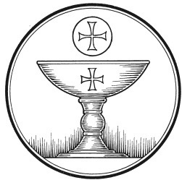
The Service of the Sacrament
This greeting marks a new service, so to speak. These ancient introductory words & phrases help to highlight, celebrate and bring attention to the Sacrament.
M: The Lord be with you.
C: And also with you.
M: Lift up your hearts.
C: We lift them up to the Lord.
M: Let us give thanks to the Lord our God.
C: It is good and right so to do.
M: It is truly good and right that we should at all times and in all places give you thanks, O Lord, holy Father, almighty and everlasting God, through Jesus Christ, our Lord, who brought the gift of salvation to all people by his death on the tree of the cross; so that the devil, who overcame us by a tree would in turn by a tree be overcome. Therefore with all the saints on earth and hosts of heaven, we praise your holy name and join their glorious song:

HOLY, HOLY, HOLY – Sanctus
C: Holy, holy, holy Lord God of heavenly hosts:
heav’n and earth are full of your glory.
Hosanna, hosanna, hosanna in the highest!
Blessed is he, blessed is he, blessed is he who comes in the name of the Lord.
Hosanna, hosanna, hosanna in the highest.
WORDS OF INSTITUTION Matthew 26, Mark 14, Luke 22
M: Our Lord Jesus Christ, on the night he was betrayed, took bread; and when he had given thanks, he broke it and gave it to his disciples, saying: “Take and eat. This is my ✙ body, which is given for you. Do this in remembrance of me.”
The Words of institution both proclaim the words of Jesus to the congregation and sets apart the bread and wine for the Lord’s Supper.
Then he took the cup, gave thanks, and gave it to them, saying, “Drink from it all of you; this is my ✙ blood of the new covenant, which is poured out for you for the forgiveness of sins. Do this, whenever you drink it, in remembrance of me.”

PEACE OF THE LORD – Pax Domini John 20:19
M: The peace of the Lord be with you always.
C: Amen

O CHRIST, LAMB OF GOD – Agnus Dei John 1:29
C: O Christ, Lamb of God,
you take away the sin of the world;
have mercy on us.
O Christ, Lamb of God,
you take away the sin of the world;
have mercy on us.
O Christ, Lamb of God,
you take away the sin of the world;
Grant us your peace. Amen.

DISTRIBUTION
Those who will be receiving Holy Communion today may wish to read Personal Preparation for Holy Communion, found on page 156 in the front section of the hymnal. This page helps us put into practice what the Bible encourages: “Everyone ought to examine themselves before they eat of the bread and drink from the cup.” (1 Corinthians 11:28)
Christ Lutheran Church confesses and practices the Biblical teaching of a Closed Communion. We ask that only members of the Wisconsin Synod [WELS] or the Evangelical Lutheran Synod [ELS] join us at the Lord’s Table. If you have questions concerning our communion practice, or would like to inquire about how you, too, can commune with us, please speak with the Pastor following the service.
THE SONG OF SIMEON
C: Lord, now you let your servant, depart in peace
According to your word.
For my eyes have seen your salvation,
Which you have prepared before the face of all people,
A light to lighten the Gentiles
And the glory of your people Israel.
M: We give thanks, almighty God, that you have refreshed us with this holy supper. We pray that through it you will strengthen our faith in you and increase our love for one another. We ask this in the name of Jesus Christ, our Lord, who lives and reigns with you and the Holy Spirit, one God, now and forever.
C: Amen.
THE BLESSING
M: The Lord bless you and keep you.
The Lord make his face shine on you and be gracious to you.
The Lord look on you with favor and ✙ give you peace.
C: Amen.
CLOSING HYMN Christ, the Life of All the Living| CW 114

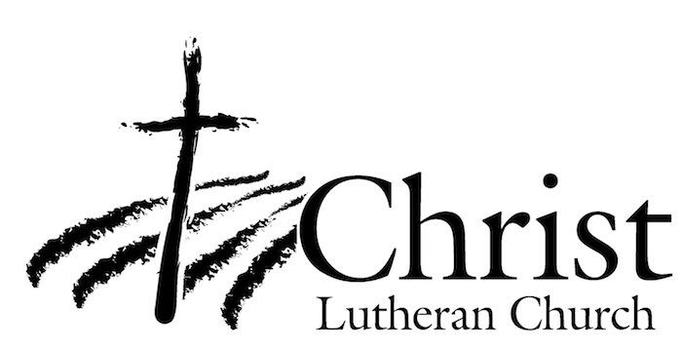
13009 N. Elderberry Ct.
Lodi, CA 95242
www.christlodi.org
209-368-6250
Pastor Timothy Leistekow
WELCOME TO CHRIST EV. LUTHERAN CHURCH!
We preach a message of forgiveness, hope and peace
through the death and resurrection of Jesus Christ.
Families and individuals of all ages will find opportunities
both to grow and to serve.
Our mission statement:
Look what Christ is doing!
He binds us together in fellowship
He gathers us in for worship
He builds us up for service
He sends us out with the gospel

“Now you are the body of Christ,
and each one of you is a part of it.”
(1 Corinthians 12:27)

